Overview of the Data:
The Data is taken from a survey project called as the Climate Change in the American Mind (CCAM), which was collected by the Yale program on the Climate Change Communication and George Mason University. The data is collected from 2008 – 2024, with 31 survey waves, over 35,000 residents. Opinions are collected on climate change with demographic and political information by the U.S. citizens aged above 18. There are different sections involved in the survey about climate change, policy support, risk perceptions and characteristics. For example, a question is asked whether the individual think the climate change is happening, out of the total opinions collected 68% individual answered “Yes”, while 32% responded “No” or “Not Sure”.

Public opinions on climate change over time were collected by the CCAM. After multiple rounds of survey, the data is collected on individual’s belief on the climate change. Our goal is to build a model that understands the data and can predict an individual’s belief in climate change based on their demographics like age, education, political ideology, and scientific reasons on climate change. We think factors political and scientific ideology play a strong influence on the people beliefs, while age and education are important demographic characteristics.

Data Cleaning:
- Missing Values – There are missing values in the data. The data coded as “no answer” or “-1”, were treated as empty values, and the count of these values are very low. To avoid complexity, we removed the missing data records on our interest variables (happening, ideology, sci_consensus). The total data after handling the missing values are 33,000.
- Outliers – Numeric data is checked for the outliers. The age variable has a limit of age 18 – 98 years, and every response is in those limits, and there are no outliers. Other factors which are categorical, or ordinal had valid ranges.
- Deleting unwanted columns: The dataset has many unwanted columns like household information, policy preferences which are not useful for our research question. For better solution we remove those columns.
- In the column happening, three choices are changed into two. “No” and “Not sure” were grouped into “0” and “yes” was changed into “1”. Values in the column’s education, political views and scientific consensus are corrected into right order. And also in numeric values, decimals are removed and made them to the round figure.
Finally, the data is cleaned and ready for the model selection.

Variable Selection:
For the predictive modeling, we observed one dependent and four independent variables.
- Dependent variable (happening): For the research question, “Do you think climate change is happening?” originally, the variables are coded as 1=No, 2=Not sure, 3=Yes, and after the cleaning of the data we changed to 0=No & Not sure and 1=Yes. After this the percentage of people believing the climate change is about 69%.
- Independent variables:
  - Age: All the people who are participated in the survey are between 18 to98, and most of them are in their 50s. This numeric variable is used to check the belief about climate change.
  - Education (edu): 1 to 14, scale is used for the level of education, having 1 lowest and 14 highest. This is used to check the levels of education relation with the climate change.
  - Political thinking (ideology): 1 to 5 scale is used, 1 being liberal and 5 means conservative, think helps how political views affect the climate change beliefs.
  - Scientific Consensus sci_consensus): 1 t0 4 scale is used, on how people agree with the scientific reasons on the climate change or not.

Model Technique:

Since our outcome will only have two outcomes like believes or does not believe the climate change is happening, we used a logistic regression model. This model is best suited for binary (yes/no or 0/1) outcomes. Logistic regression is better than the linear regression for this kind of the data. This model also tells us about the odds of believing in climate change.
Also, logistic regression is also accurate and very easy to understand. The results are shown in odds ratios, which are easy to understand.
- Odds ratio which is above 1 means people believing in the chance of having climate change.
- Odds ratio which is below 1 means no believing in the chance of having climate change.
For example, if the odds ratio of education is 1.20, then it means the people who have access to the education is 20% more believe in climate change than with the less education, and remaining factors with be the same.
We used statsmodels library in the python. The p-value for the model is 0.001 and this means it is statistically more important. This is 27% in the variation in belief, this is a very good result for the data collected in the survey.

Results:

We used logistic regression to find the people belief in climate change happening with the factors like age, education, political awareness, and scientific consensus.
- Age – odds ratio is 1.00 – from the odds ration we ca find that the age factor has no effect on the climate change belief. Old and younger people have the same beliefs when it comes to climate change.
- Education – odds ratio is 1.05 – people who are educated are 5% belief on the climate change than the people who are not educated.
- Political Ideology – odds ratio – 0.43 – The people who belief the climate change happening are the liberals. The conservatives do not actually believe the change in the climate change.
- Scientific consensus – odds ratio is 2.34 – Most people belief the scientists who agree on the climate change is happening.
The model is statistically important i.e., p<0.001 with 27% variation in the belief. This is the strongest result for the data collected.

McFadden R square = 0.264, NagelKerke R square = 0.393 => the model explains upto 26-39% in belief variation.
Accuracy (Test) = 0.776, the model gives results correctly 78% of the responses.
AUC (Test) = 0.834 => differentiating believers from the non-believers.

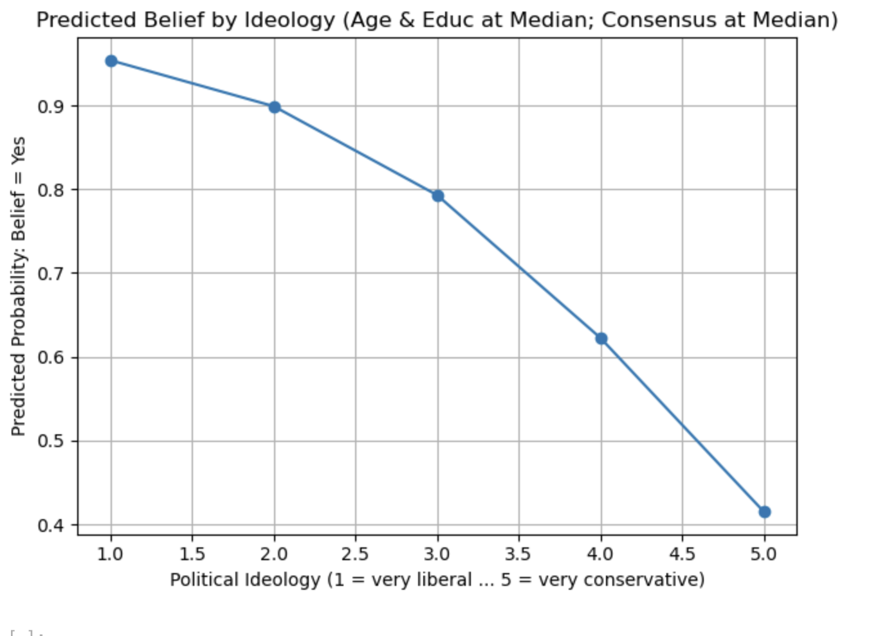

The line chart shows the relation between the belief on the climate change by the conservative and liberals. The predicting possibility has dropped from 90% to 40%, even with the factors like age, education and awareness kept unchanged.

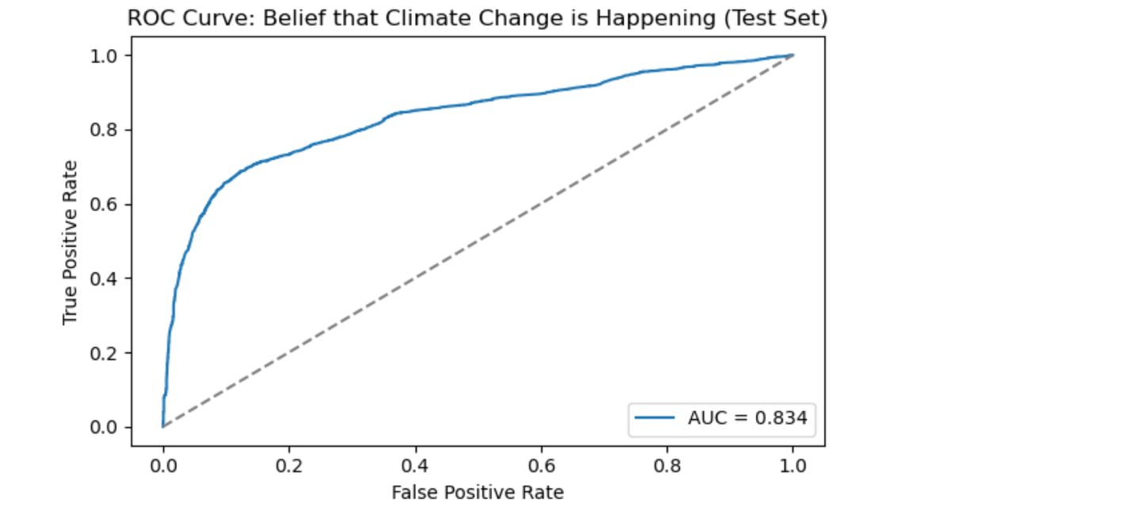

The ROC line shows the separation of believers from the non-believers.
Interpretation:
Political awareness and scientific awareness are the two factors that play a key role in the public opinion on the climate change. While education plays a small positive role, political ideology has a strong impact. People with more liberal and knows about the scientific principle are more likely to believe climate change.
Results:

Political awareness and Scientific consensus are the two strongest factors that drive people to believe the climate change is happening. Education plays a small positive role while age does not provide any positive impact in believing in climate change. This helps why discussing about the issues in the climate often divide people along political lines.

Policymakers, educators, and environmental organizations can better understand the results and make better awareness in the campaigns. Awareness should be built among the lower belief people. Campaigns like over 96% scientists believe in climate change, can change the people perspective on the climate change. Also schools, media can help people understand the science behind the climate change.

